Introduction
Prediction markets have experienced remarkable growth recently, with volume increasing over tenfold from $1.71B to $17.4B in the last year. Kalshi became largely recognized during the 2024 presidential election when their implied odds ended up being more accurate than polling odds, and has more recently been running aggressive advertising campaigns, pushing hard to expand their brand recognition. Polymarket has been on a similar path, running publicity stunts like the NYC free grocery store, and recently being re-legalized in the US. It is clear that prediction market popularity is on an upward trend and doesn’t appear to be going anywhere as long as legislation allows for it. We believe that these markets offer a fascinating aggregation of the collective beliefs of their traders. Through financial incentive, they serve as a real time test of the “wisdom of the crowd” by translating beliefs into implied event probabilities.
While much of the media attention surrounding prediction markets covers long-horizon event predictions such as elections, wars, and macro outcomes, there is a smaller but equally interesting corner of these markets that operates on a much quicker time horizon. Both Kalshi and Polymarket offer 15-minute Bitcoin and Ethereum price direction contracts in which traders place bets on whether or not the BTC or ETH price will be above or below a given spot price for every 15-minute increment of the day. This simple binary question generates a continuous stream of implied probabilities that are updated in real time, creating an unusual opportunity for analysis. While prediction market calibration has been studied in the context of political and macroeconomic event markets, there is no existing literature examining short horizon cryptocurrency contracts. Determining whether these probabilities are well calibrated, accurate, and informative will provide essential information for traders about market microstructure as well as motivation for algorithmic trading of these markets. This study aims to answer the question: Do Kalshi prediction market probabilities for BTC and ETH 15-minute price direction contain exploitable directional signals, and how do market calibration, intraday seasonality, momentum decay, and cross-asset information jointly determine realized prediction accuracy?
Literature Review
The theoretical foundation for treating prediction market prices as collective belief aggregators stems from Wolfers and Zitzewitz (2004), whose survey of early prediction markets across a wide range of forecasting contexts establishes the core idea that this study builds on. They demonstrate that prediction market forecasts are typically accurate and outperform most simple benchmarks, and that binary contracts, like the ones sold on Polymarket and Kalshi, yield direct insights into the market's expectations of future event probabilities. They treat the contract price as a mechanism for revealing dispersed private information: a collection of traders with real capital at risk are financially incentivized to trade toward true expectations, producing an aggregate probability that is generally more accurate than individual forecasts. The 15-minute BTC and ETH price direction contracts examined in this study are a direct example of this mechanism, with quick resolution times allowing for the aggregation process to be observed live in a single trading session.
Whether contract prices are actually well calibrated to realized outcomes is a question with mixed but generally positive literature. Page and Clemen (2013) provide an examination of this question using transaction data from InTrade, an early web based prediction market that shut down in 2013. They find that markets are reasonably well calibrated when time horizons are short, but exhibit a long shot bias at longer time horizons, underpricing high probability events and overpricing low probability events. Critical for this study, they find that this miscalibration largely disappears as contract expiration approaches, suggesting that short horizon contracts reflect reliable pricing in terms of probability estimates. A more recent study by Agarwal et al. (2025) examining 292 million trades across 327,000 binary contracts on Kalshi and Polymarket, finds that calibration is domain dependent, meaning that the context behind the event is important. This motivates examining short term crypto markets as their own distinct category rather than assuming they calibrate similarly to, say, political markets.
A recent paper by Mohanty and Krishnamachari (2026) studies whether daily probability changes in Kalshi macro event contracts (rate cut probabilities, regression risk, etc.) forecast cryptocurrency realized volatility. They find meaningful predictive content, particularly for recession risk signals, but their analysis operates at daily frequency and focuses on volatility rather than price direction. The present study works at 15-minute resolution and treats the prediction market probability itself as the primary signal rather than as a macro input, occupying a distinct position in the emerging literature on Kalshi as a data source.
The broader conceptual framework motivative this study is Surowiecki's (2004) argument that crowds produce reliable aggregate judgments when participants hold diverse information, act independently, and are affected by the consequences of error. Prediction markets have become the cleanest and most popular realization of this framework: prices are formed by financially incentivized participants whose errors are immediately penalized. Surowiecki specifically identifies financial markets as contexts where these conditions are most consistently met, and short-horizon binary contracts represent a particularly clean case. The outcome is unambiguous, resolution happens rapidly, and the payoff structure is simple enough to minimize confounding from risk preferences or liquidity effects. This study tests whether this mechanism produces a signal with exploitable directional content, treating the crowd's aggregate belief as a data source rather than simply evaluating its accuracy.

Data Collection
While Kalshi offers an API to interact with market data, granular historical odds are not provided directly. To solve this issue, data sets were built using custom Python scripts that continuously polls the Kalshi Trade API at 10 second intervals. Separate scripts were used and separate data sets were constructed for BTC markets and ETH markets. The script targets the 15-minute price direction contracts, monitoring for and switching between markets in real time as new ones go live.
At each 10 second interval, the script computes the mid-price probability of an upward price movement by averaging the best bid and ask prices at that time. This mid-price is labeled as the market's implied probability of an upward movement, P(UP), with P(DOWN) being the implied probability of a downward movement, calculated as 1 - P(UP). To reduce noise, rather than logging every 10 second observation, the script takes the average of the P(UP) and P(DOWN) readings within 1-minute windows throughout the contract. It also creates a momentum term, calculated by the change in P(UP) from the previous minute. This yields 15 data points for each variable every contract period.
Upon market expiration, the script loops back and queries the API for the final outcome of the contract. Using this information, it also determines the accuracy of the majority’s predictions at each time stamp. All observations are written to a CSV with the following fields: Timestamp, P(UP), P(DOWN), Momentum, Majority Prediction, Actual Outcome, Correctness, Market ticker, and Volume.
Prior to analysis, a separate Python script is then used to clean the raw data, removing any invalid observations. An observation is deemed invalid if it does not contain exactly 15 logged data points, did not have a resolved outcome, or had missing values in any of the columns. Markets failing any of these criteria were dropped entirely. This ensures that the dataset contains only fully observed, resolved, and actively traded market periods, avoiding markets that could bias signal analysis later on. Data collection occurred opportunistically over a six week window, yielding roughly 2,200 BTC contracts and 1,900 ETH contracts.

Exploratory Analysis
Before constructing predictive features, three descriptive analyses were conducted to characterize how Kalshi BTC 15-minute contract probabilities behave across the sample. These analyses motivate specific modeling choices in the sections that follow and establish baseline properties of the market that any signal extraction approach must account for.

Feature engineering
Each contract is collapsed to a single row of summary statistics before modeling; treating within-contract rows as independent would violate the independence assumption and inflate sample size.
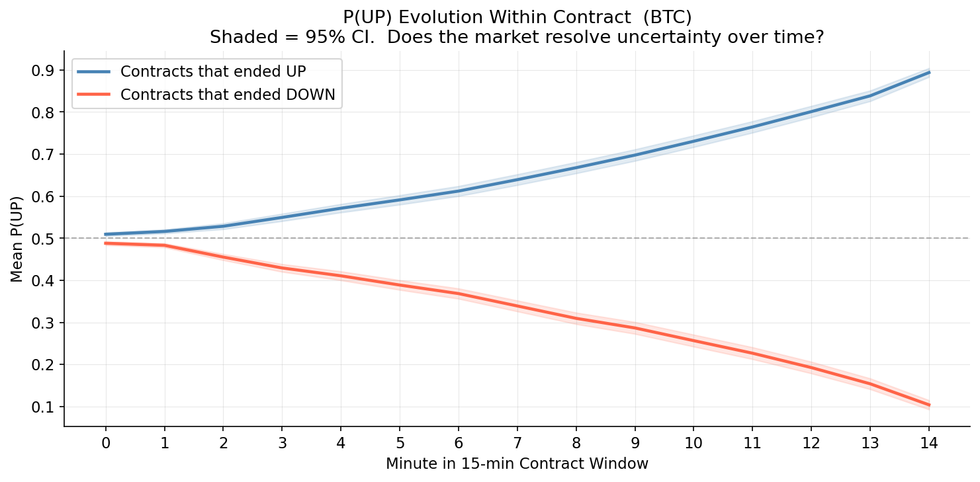
Figure 1 motivates the feature design. Contracts resolving UP show monotonically rising P(UP) from open; contracts resolving DOWN show monotonically falling P(UP). This divergence establishes that early directional movement carries content beyond the opening probability level and motivates the momentum features that follow.
Three feature groups are constructed using only the first few minutes of each contract, ensuring no future information enters the model. The first captures market state at open: opening P(UP), conviction spread (|P(UP) − 0.5| × 2, normalized to [0, 1]), and log-transformed opening volume. The second captures early directional movement: change in P(UP) from minute 0 to 1, change from minute 0 to 3, and mean and standard deviation of P(UP) over the first five minutes. The third tests whether the concurrent ETH contract carries information about BTC outcomes. At any given moment, BTC and ETH 15-minute contracts are open simultaneously, priced by participants responding to the same macro environment. Opening P(UP) across matched BTC and ETH contracts is correlated at r = 0.465, suggesting a shared sentiment factor. ETH opening P(UP) and ETH 3-minute momentum, matched to the same BTC contract open timestamp, test whether this co-movement adds predictive value beyond the BTC signal alone.
Feature | Description
opening_pup_btc | P(UP) at minute 0
conviction_spread | |P(UP) - 0.5| x 2, range [0,1]
volume_log | log(1 + opening volume)
momentum_1min | P(UP)[t=1] - P(UP)[t=0]
momentum_3min_btc | P(UP)[t=3] - P(UP)[t=0]
mean_pup_5min | Mean P(UP) over first 5 minutes
pup_vol_5min | Std of P(UP) over first 5 minutes
opening_pup_eth | ETH P(UP) at matched contract open
momentum_3min_eth | ETH P(UP)[t=3] - P(UP)[t=0]
btc_eth_divergence | BTC P(UP) minus ETH P(UP) at open (XGBoost only)
Table 1. Contract-level feature set. The divergence term is excluded from logistic regression because it is a linear combination of the two opening P(UP) features, producing a singular design matrix.

Modeling approach
Three models are estimated in sequence to isolate the contribution of each feature layer. The baseline logistic regression uses three features: BTC opening P(UP), BTC 3-minute momentum, and hour of contract open. These set the performance floor for a minimal specification. Logistic regression is appropriate because training sets within each cross-validation fold contain roughly 1,000 to 1,500 contracts, too few to support high-dimensional nonlinear models without overfitting. Coefficients are interpretable as log-odds contributions, supporting the feature importance analysis that follows. The extended logistic regression adds the full feature set from Table 1 for eleven predictors total; btc_eth_divergence is excluded because it is a linear combination of the two opening P(UP) features and produces a singular design matrix.
XGBoost serves as a nonlinear benchmark. Gradient-boosted trees do not require orthogonal features, so the divergence term is reinstated for twelve features total. Hyperparameters are set conservatively (max depth 4, learning rate 0.05, 80% row subsampling) to limit overfitting on the available training sample. SHAP values decompose each prediction into per-feature contributions, providing a model-agnostic importance ranking. All three models use 5-fold time-series cross-validation with folds ordered chronologically, so every prediction is generated on data the model has not seen. The majority-class baseline, which predicts UP for every contract, achieves 52.5% accuracy and serves as the reference point for all comparisons.

Results
Table 2 reports out-of-sample classification performance across all three models on 1,595 contracts from the held-out folds.
Model | Accuracy | AUC-ROC
Majority baseline | 52.5% | 0.500
Baseline LR (3 features) | 64.4% | 0.703
Extended LR (11 features) | 65.4% | 0.692
XGBoost (12 features) | 65.1% | 0.694
Table 2. Out-of-sample classification performance from 5-fold time-series cross-validation, with folds ordered chronologically.
All three models exceed the majority-class benchmark by a margin substantially larger than fold-to-fold variation. The baseline logistic regression alone gains 11.9 percentage points of accuracy and 0.203 of AUC-ROC, confirming that three same-asset features carry meaningful predictive content. The extended specification adds 1.0 percentage point of accuracy while AUC falls marginally (0.703 to 0.692): the cross-asset and momentum features tighten decisions at the boundary without uniformly improving probability ranking across all thresholds.
SHAP values from XGBoost (Figure 3) provide a model-agnostic importance ranking. Mean P(UP) over the first five minutes is the dominant predictor, confirming that the smoothed early-window signal carries more information than the instantaneous opening level. The decisive finding is among cross-asset predictors: ETH 3-minute momentum ranks second overall and ETH opening P(UP) ranks above BTC’s own opening probability. The concurrent ETH market contributes more predictive power to BTC outcomes than the BTC opening level itself.
The lead-lag analysis explains why. The cross-correlogram between BTC and ETH P(UP) at lags −3 to +3 minutes across 1,920 matched contract windows (Figure 2) peaks at lag 0 (r = 0.782, p < 0.001) and falls symmetrically at all other lags, with no statistically significant difference between positive and negative lags. Neither market leads the other: both price information simultaneously. ETH is informative about BTC not because it processes information first, but because the two markets share a latent crypto sentiment factor that is sometimes priced more completely into ETH at a given contract open. A concurrent ETH feature captures this shared factor; a lagged ETH feature would not.
XGBoost matches the extended logistic regression to within rounding (65.1% vs. 65.4% accuracy; AUC 0.694 vs. 0.692). A McNemar test on out-of-sample prediction disagreements yields p = 0.866, confirming that the gap is not statistically significant. Nonlinear interactions do not improve on a well-specified logistic regression: the available signal is approximately linear in these features, and feature engineering rather than model class is the binding constraint on accuracy.
The classification result is internally robust along three dimensions. Linear and nonlinear models reach indistinguishable accuracy (McNemar p = 0.866), so feature engineering rather than model class is the binding constraint. The chronologically ordered time-series cross-validation ensures no future information enters any training set, so reported accuracy reflects genuine out-of-sample generalization. And the contemporaneous lead-lag peak (r = 0.782 at lag 0) provides a structural reason for the cross-asset finding: the two markets share a common sentiment factor rather than one consistently leading the other, which is what allows ETH features to add predictive power without implying any temporal information advantage.
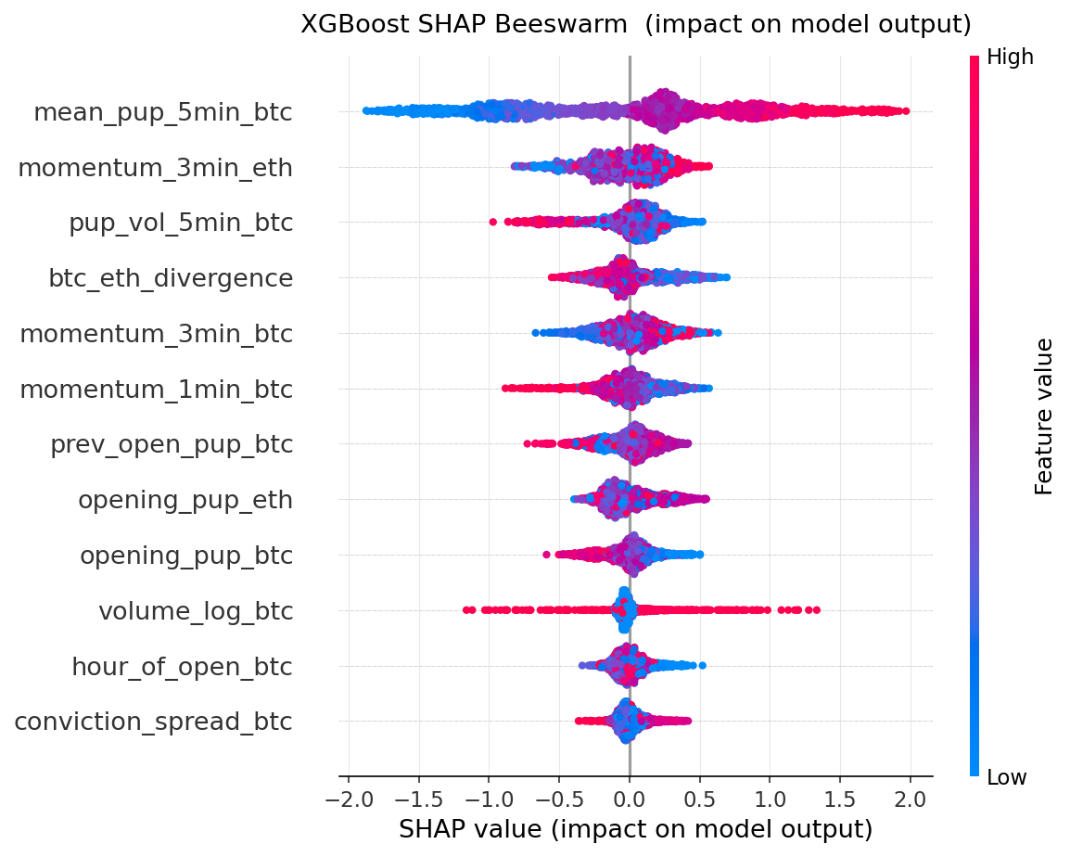
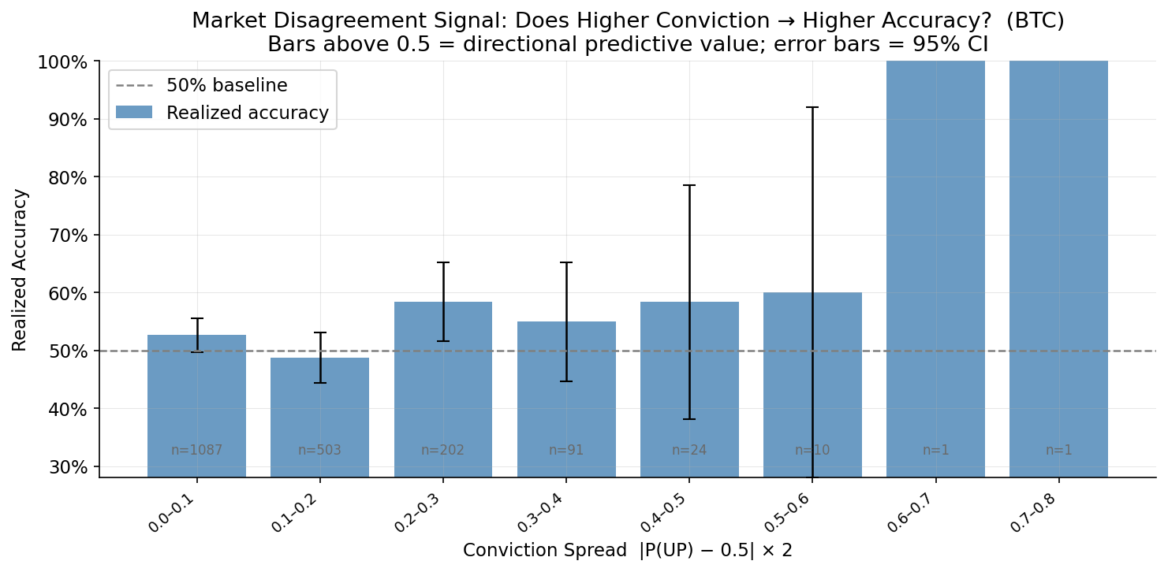

Applications and Future Directions
The most direct application treats Kalshi P(UP) as a financially incentivized sentiment feature for predicting the underlying. The lead-lag analysis presented here was between two prediction markets and found contemporaneous co-movement; the more consequential test for using PM as a trading signal is the lead-lag between PM probability and BTC or ETH spot price. If P(UP) carries directional information not already contained in standard spot features — recent returns, order book imbalance, funding rate — sentiment-augmented models executed on liquid perpetual futures venues become the natural deployment target. Execution frictions on BTC and ETH perpetuals are several basis points round-trip, orders of magnitude below the spread, fee, and capacity constraints that bound Kalshi itself, so the relevant economic question shifts from viability against Kalshi’s microstructure to incrementality above a spot-features baseline.
Conviction spread — |P(UP) − 0.5| × 2 — is a directly observable market-implied uncertainty measure at 15-minute granularity. Intraday volatility forecasts are typically built from GARCH-family models or HAR-RV regressions on past realized variance, both of which lag during regime transitions. A PM-derived uncertainty input could improve these forecasts at exactly the points where the lagged-variance models break down. A natural complementary test compares PM-implied uncertainty against implied volatility from short-dated BTC and ETH options to determine whether PM uncertainty captures information already priced into options markets or contributes independently.
The cross-asset finding — that ETH features dominate BTC’s own opening probability for BTC outcomes — suggests a latent crypto-sentiment factor that loads across multiple assets. A natural extension estimates this factor from a panel of PM contracts (BTC, ETH, and additional tokens as venues expand their offerings) and uses it as a systematic risk factor in a multi-asset model. This parallels the use of common factors in equity markets and fixed income, with a sentiment factor potentially explaining short-horizon crypto co-movement that price-based factors miss. The factor itself, recovered from financially incentivized belief rather than from price residuals, is a quantitatively distinct object from existing crypto-momentum or crypto-vol factors.
Beyond directional trading, a calibrated probability series is a candidate input for regime detection and risk overlays. Periods of unusually low aggregate conviction across contracts may signal elevated-uncertainty regimes in which position sizing across an unrelated strategy should contract; periods of extreme conviction (P(UP) near 0 or 1) may signal consensus tail-risk views useful as a hedging trigger. Both uses treat PM data as a conditioning variable rather than a primary signal, which lowers the bar for usefulness: the data needs to add information at the regime level, not to generate standalone alpha.
More broadly, prediction market probabilities occupy an underdeveloped corner of the alternative data landscape. Unlike text-based or survey-based sentiment proxies, the signal is financially incentivized, continuously priced, and resolved against ground truth within minutes. This makes it suitable both as a primary input to quant strategies and as a calibration benchmark for noisier sentiment sources — a Bayesian ensemble combining high-precision, low-coverage PM signals with high-coverage, lower-precision text-based sentiment is a natural research direction. As Kalshi and other regulated venues expand their crypto contract offerings, the historical depth required to validate these applications across regimes becomes increasingly available.

Limitations
The primary constraint is the length of the data window. Six weeks yields approximately 2,200 BTC contracts and 1,900 ETH contracts, enough to identify and validate a signal but representing a single uninterrupted market episode. Results from one continuous period cannot be assumed to generalize across volatility regimes or future periods in which Kalshi’s participant composition or liquidity profile may differ. A dataset covering multiple distinct regimes is needed to assess whether the signal persists or is specific to conditions present during this collection window.
No backtest of trading performance is reported. Kalshi’s bid-ask spreads, 7% withdrawal fee, and per-contract volume caps place realistic execution costs above any level at which the classification edge identified here would remain economically positive. A defensible economic evaluation would require modeling the venue’s microstructure directly rather than reporting a stylized binary payoff at this granularity.
The model is trained and evaluated on BTC-denominated contracts only. Extension to ETH is a natural next step but requires retraining and testing whether the same feature structure transfers. The cross-asset features are used here in one direction only, incorporating ETH signals to predict BTC outcomes; the reverse channel has not been examined. XGBoost hyperparameters and feature construction choices were not subjected to a formal grid search, though the conservative settings were chosen specifically to limit overfitting risk.

Conclusion
Kalshi 15-minute BTC contracts carry a statistically real directional signal. Three same-asset features raise classification accuracy from a 52.5% majority-class baseline to 64.4%; the extended specification including cross-asset ETH features reaches 65.4% accuracy and 0.692 AUC-ROC, with a McNemar test confirming that nonlinear models do not add to a well-specified linear one. These results hold strictly out of sample under chronologically ordered cross-validation. Whether this edge is economically exploitable on Kalshi is a separate question this study does not attempt to answer: realistic spreads, fees, and per-contract capacity place the relevant frictions above any level at which a meaningful backtest could be conducted on this dataset.
The more substantive finding concerns information structure rather than tradability. ETH opening P(UP) and ETH 3-minute momentum are more informative about BTC outcomes than BTC’s own opening probability, and the lead-lag cross-correlogram peaks symmetrically at lag 0 (r = 0.782) with no significant directional asymmetry. The two markets are not in an information race; they are simultaneously exposed to a shared crypto sentiment factor that is sometimes priced more completely into one venue than the other at a given moment. For researchers building signals from prediction market data, this implies cross-asset aggregation is valuable not because any single market is faster but because each market provides a partial draw on the same underlying sentiment.
These contracts are most usefully framed as a measurement tool for high-frequency, financially incentivized crowd belief. P(UP) is not a sentiment score derived from text or extrapolated from price history. It is a continuously repriced aggregate of trader views with real capital at risk, distinguishing it from survey-based or social-media sentiment proxies where there is no direct cost to holding a wrong belief. Short-horizon Kalshi contracts are among the clearest expressions of the wisdom-of-crowds mechanism at high frequency, and the signal identified here provides a measurable directional sentiment series at a granularity not available from other alternative data sources.
This study establishes the measurement. Kalshi 15-minute crypto contracts contain a calibrated, financially incentivized directional sentiment signal whose statistical properties are characterized here. Whether that signal is incremental to spot-based features in the prediction of crypto returns, and how the broader applications outlined above translate into deployable strategies, are the empirical questions this work opens.

